**Centennial-scale gaps in a 5,500-year trajectory of acroporid growth from a hurricane-prone Caribbean coral reef**

Alexis E Medina-Valmaseda

Paul Blanchon*

Juan Pablo Bernal

Liliana Corona

Rosa E. Rodríguez-Martínez

Alex Correa-Metrio

Edlin Guerra-Castro

*Corresponding author

**Abstract**

Consistency in the composition of shallow-water acroporid communities throughout the late Pleistocene has led some to suggest that the baseline condition of Caribbean reefs is a continuous cycle of growth, disturbance, and recovery mediated by hurricanes. As such, the regional demise of acroporids over the last 50 years is seen as unprecedented. Yet the paleoecological trajectory of acroporid growth in fossil reefs is largely unknown, so cycle constancy is unproven at an ecological scale. Here, we reconstruct a 5,500-year acroporid trajectory from a hurricane-prone fringing reef off the northeast Yucatan coast and find that growth is not constant but punctuated by centennial-scale gaps. These gaps, which also occur in a reconstruction from Barbados, coincide with hurricane-frequency anomalies and are consistent with local extirpation of acroporids following intense hurricane strikes. On each devastated reef, acroporids took hundreds of years to recolonize their former habitat likely due to naturally impaired sexual recruitment combined with hurricane-induced substrate changes. A comparison of trajectories show extirpation-recolonization cycles occur at different times on each reef, so gaps do not coincide. This produces a constant paleoecological baseline which affirms that the ongoing regional demise of acroporids is unprecedented over the last 14,000 years and portends their absence on degraded reefs for hundreds of years into the future unless mitigated by restoration.

**Introduction**

Caribbean reefs were once covered by dense and diverse communities of corals. The first underwater surveys reported a lush coral cover with particularly dense thickets of robust-branching acroporids over the crest and reef-front zones (Goreau, 1959; Kornicker and Boyd, 1962; Stoddart, 1962; Shinn, 1963; Geister, 1977; Gladfelter et al., 1978; Rützler and Macintyre, 1982). The dominance of acroporids in wave-swept habitats stemmed from their large size and close colony spacing, which produced interlocking surf-resistant thickets capable of absorbing wave energy and modulating the surrounding environment (Adey and Burke, 1976; Geister, 1977; Lugo-Fernandez et al., 1998). Their success in such habitats is attributed to a 5-10 cm/yr growth rate, which is an order of magnitude higher than other reef-building species, and an efficient reproduction via asexual fragmentation and re-sheeting of dead colonies(Gladfelter et al.,1978; Highsmith et al., 1980; Jordán-Dahlgren, 1992; Fong and Lirman 1995; Lirman and Fong 1997; Pratchett et al 2015). These traits enabled a quick recovery from storm damage, creating a continuous cycle of disturbance and recovery over ecological time scales (Woodley, 1992; Fong and Lirman, 1995; Bruckner, 2002). This cycle is supported by the internal structure of both Holocene and Pleistocene reef-crest units which are composed predominantly of hurricane-generated acroporid clasts (Blanchon et al., 1997; Perry, 2001; Macintyre et al., 2001; Blanchon and Perry, 2004; Blanchon et al., 2017; Blanchon et al., 2021).

Today, in stark contrast to the early surveys, reef-crest habitats lack large corals due to the mass mortality of acroporids and steep decline in coral cover over the last 50 years (Davis, 1982; Gladfelter, 1982; Rogers, 1985; Dustan and Halas, 1987; Goreau, 1992; Porter and Meier, 1992; Bythell and Sheppard, 1993; Hughes, 1994; McClanahan and Muthiga, 1998; Gardner et al., 2003; Miller et al., 2006; Jackson et al., 2014; Precht et al., 2016). None of these degraded reefs have subsequently shown significant evidence of recovery, apparently due to the absence of recruitment (Hughes and Tanner, 2000; Bruckner, 2002; Williams et al., 2008; Rogers and Muller, 2012; Rodríguez-Martínez et al., 2014). Given their ecological and geological importance, this lack of recovery has not only transformed shallow reefs into less complex habitats dominated by non-reef-building species (Hughes, 1994; Shulman and Robertson, 1996; McClanahan and Muthiga, 1998; Hughes et al., 2007; Green et al., 2008; Cramer et al., 2021) but has led to widespread changes in reef structure and function which threaten to impair their future development (Alvarez-Filip et al., 2009; Perry et al., 2013).

The direct cause of the regional decline in Caribbean acroporids is widely attributed to the combination of increased hurricane intensity (Gardner et al.,2005; Emanuel, 2005; Vecchi et al., 2021; Mudge and Bruno, 2023) and disease outbreaks (Gladfelter, 1982; Randall and van Woesik, 2015; Miller et al., 2022). But the proximate cause is contested, involving either chronic anthropogenic disturbance preventing recovery, or a regional increase in sea-surface temperature rendering coral populations susceptible to disease and bleaching (Hayes et al., 2001; McWilliams et al., 2005; Randall and Szmant, 2009; Eakin et al., 2010; Bruno and Valdivia, 2016; Cramer et al., 2020; Dietzel et al., 2021; Alves et al., 2022).

Regardless of the cause, the historical demise of acroporids over the last 50 years is considered unprecedented on millennial timescales (Aronson and Precht, 1997; 2001; Pandolfi, 2002; Wapnick et al., 2004; Pandolfi and Jackson, 2006; Toth et al., 2019; Cramer et al., 2021). This claim is based on the compositional consistency between modern and fossil reef communities, which demonstrate that acroporids have been the regional baseline since the beginning of the Pleistocene (Jackson, 1992; Greenstein et al., 1998; Pandolfi and Jackson, 2006; Precht and Miller, 2007; Toth et al., 2019). Despite this apparent community consistency, few studies have sought to establish the paleoecological growth trajectory of acroporid assemblages in fossil reefs to determine if there have been comparable widespread die-offs in the past. Yet the degree of constancy in past acroporid growth provides a contextual key to understanding the cause of its historical demise, especially given that both the late Pleistocene and Holocene have encompassed significant intervals of natural climatic variation (Haug et al 2001; Donnelly and Woodruff, 2007). Although the impact of anthropogenic activity on reef decline is undeniable (Hughes et al., 2003; Knowlton and Jackson, 2008; Mora, 2008), the widespread demise of reefs in sparsely populated areas (Alvarez-Filip et al., 2009; Bruno and Valdivia, 2016) necessitates differentiating the proximate cause of regional decline from natural variation.

Here we reconstruct the paleoecological trajectory of acroporid growth over the last 5500 years from a hurricane-prone fringing reef at Punta Maroma, off the northeast coast of the Yucatan Peninsula, Mexico (Fig 1). The site is well suited for the task because not only has the historical growth of shallow acroporids been monitored since the late 1970s, showing a similar decline to other reefs in the region (Jordán-Dahlgren, 1992; Rodríguez-Martínez, 1993), but the geological structure and composition of the reef deposit has been reconstructed from a U-series-dated core transect (Blanchon et al., 2017). This transect shows that the reef consists of a layer of hurricane-generated acroporid clasts that have retrograded shoreward over the last 5500 years, driven by hurricanes and sea-level rise. By characterising the near-surface chronology of this reef at a sub-centennial resolution, we determine the ecological trajectory of acroporid growth over this interval and its temporal response to natural disturbance, thereby providing a contextual baseline for the recent acroporid decline.

**METHODS**

**Study area**

Initial ecological surveys of fringing reefs from the northern Mexican Caribbean, including Punta Maroma, reported a distinct tripartite zonation: a back-reef, a crest zone (subdivided into Acropora-Millepora and barren subzones), and a reef-front (Jordan et al., 1981). The first surveys at Punta Maroma in 1979, and later in 1985, found 20-30% coral cover, dominated by *A. palmata*, which comprised up to 86% of the reef-front community (Jordán-Dahlgren, 1992; Supplementary Information).

These early surveys, however, occurred during a lull in hurricane activity. Between 1880 and 1900, four Category 2 or 3 hurricanes struck within 5 km of Punta Maroma. Yet the subsequent 85 years saw only four impacting hurricanes, all of which made landfall 50 km south, with Cozumel Island shielding Punta Maroma. The next direct strike was not until 1988 when Hurricane Gilbert, a record-breaking category 5 hurricane, devastated coastal and marine ecosystems (NOAA Historical Hurricane Tracks 150-year database, Office for Coastal Management; Meyer-Arendt,1991). Re-surveys of fringing reefs after Gilbert revealed a drastic reduction in coral cover to ~5% (Rodríguez-Martínez, 1993). A decade later, acroporids had still not recovered, with monitoring surveys showing similarly low coral cover (Supp Info).

Today, many reefs along the northeast Yucatan remain depauperate, dominated by weedy corals and macroalgae, and recent studies have not identified the same pre-disturbance zonation (Medina-Valmaseda et al., 2020). At Punta Maroma, geomorphic zones have been redefined based on slope and substrate attributes (Blanchon et al., 2017), with the reef front now comprising a shallow stump-and-boulder zone (< 3 m) and a deeper spur-and-groove zone (3-8 m). In addition, analysis of 12-core drill transect revealed that the geological structure of the reef front consists of large cobble-sized clasts of *A. palmata* (90% by volume) with subordinate in-place head corals (Blanchon et al., 2017). This clast-dominated deposit initiated beneath the spur-and-groove zone around 5,500 years ago, and subsequent sea-level rise caused it to retreat upslope, retrograding over its back-reef deposit in the process. This retrograding structure therefore points to a disturbance-recovery cycle controlled by hurricane strikes over the reef’s 5,500-year history (Blanchon et al., 2017).

**Near-surface sampling**

To determine the trajectory of acroporid growth at Punta Maroma, we sampled the substrate of the crest and reef-front zone to characterise its near-surface chronology during two field seasons in 2019 and 2021. This sampling assumes that acroporid growth and post-mortem clast transport are retained within these zones, given that previous surveys reported *A. palmata* growth to be abundant between 0-5 m depth (Jordán et al., 1981). Although the geomorphological boundary of the reef-front zone extends to a maximum depth of 8 m, this depth interval is still consistent with the acroporid growth habitat because sea level has risen ~3 m over the last 5500 years (Blanchon et al., 2017). Consequently, sampling the entire reef-front zone should provide a representative picture of the acroporid growth trajectory over this time interval.

To sample near-surface age, we collected coral clasts from shallow sub-meter-sized pits excavated into the stabilised, but largely uncemented reef-front substrate (Fig. 1). The selection of sample sites was based on the need to cover downslope reef-front zones and their lateral extent across the reef structure. For this reason, we collected samples along several transect-like traverses perpendicular to the crest as well as more isolated single sites distributed haphazardly along the reef-front.

In total, 52 pits were excavated (Supp Info). In each, we prioritised the collection of acroporid species in order to reconstruct their trajectory. However, we also collected a lesser number of non-acroporid species to determine the degree of community consistency (samples were identified to species level where possible). In addition to pit samples, we include near-surface samples from 10 cores of the 12-core drill transect, with 9 samples taken from the top 1 m of each core, and 4 samples between 1-2 m of the surface (Blanchon et al., 2017). Including near-surface samples from both pits and cores gives a total of 62 sites distributed non-uniformly over a reef-front area of ~0.65 km2 (Fig. 1)

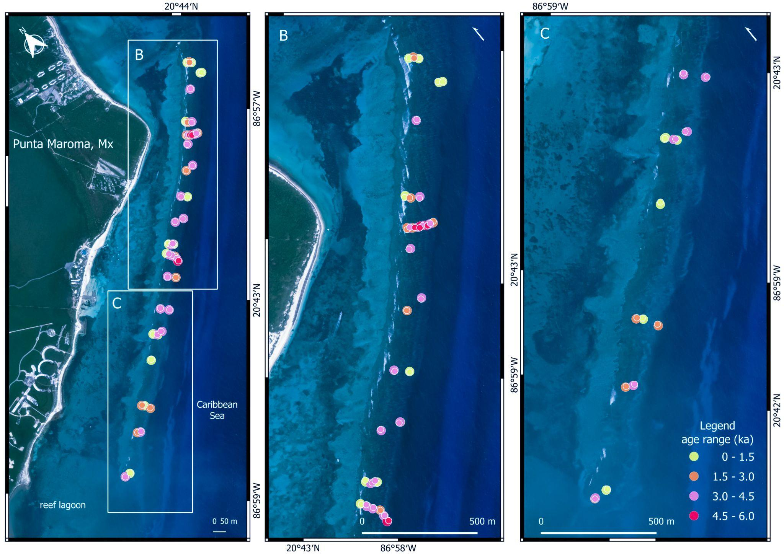

**Figure 1. Spatial distribution of sampling pits and shallow cores in the reef front at Punta Maroma**. Circle colour represents the age range (ka) for each site: Yellow <1.5 ka; Orange, 1.5-3.0 ka, Pink, 3.0-4.5 ka and Red, 4.5-6.0 ka. Esri Imagery 2D (Maxar, Earthstar Geographics, and the GIS user company) was accessed through Qgis plugin HCMGIS ([GitHub - thangqd/HCMGIS: HCMGIS Plugin for QGIS](https://github.com/thangqd/HCMGIS)), freely distributed under GNU General Public License v3.0. Geographic coordinates are represented in UTM 16N (Mexico).

**Geochronology**

Coral samples from the pits and cores were screened for dating based on the skeletal preservation state to ensure ages were uncontaminated by taphonomic alteration. Unaltered coral samples were dated using 234U/230Th radioisotope series at the Laboratorio de Estudios Isotópicos, Centro de Geociencias, UNAM, using a multi-collector ICPMS Thermo Neptune Plus Mass Spectrometer. All sample preparations were carried out in Class 100 Clean Laboratory, with typical blanks of less than 3 pg of 238U and 1 pg of 232Th. The process involved using high-purity 233U and 229Th spikes, calibrated against solutions of Uraninite in secular equilibrium (Harwell Uraninite and Schwartzwalder Mine Uranium Mineral). The dating methodology corresponds to Uranium and Thorium separation and purification following Hernández-Mendiola et al. (2011) and reported by Blanchon et al. (2017). The activity ratios were calculated considering the decay constants for 230Th and 234U reported by Cheng et al. (2013), for 238U reported by Jaffey et al. (1971), and for 232Th reported by Audi et al. (1998). The raw ages were corrected for detrital Th contribution using a two-point isochron with the atomic ratio of 232Th/238U of the detrital fraction assumed to be similar to that of the Earth's crust = 3.8 ± 1.2 (McDonough and Sun, 1995), and with [230Th/238U] and [234U/238U] equal to 1.0 ± 0.1 (Ludwig and Paces, 2002). The same constants were used for age calculation using ISOPLOT-R (Vermeesch, 2018). Repeat analyses of a mid-Holocene coral sample yields an average U-Th age of 4.59 ± 0.06 (2SE, *N*=10, MSWD 5.5) within different analytical sessions. Neither the analytical error of measured age nor the true-age variation between duplicate ages exceeded 1%. All ages and their corresponding uncertainties are represented in absolute calendar years from the moment of U-Th separation (2021 and 2023, Table 1 Supp. Info) following Dutton et al. (2017).

**Statistical resampling analysis**

Given that the production of coral clasts is related to multiple cycles of disturbance and recovery over the last 5,500 years (Blanchon et al., 2017), it is reasonable to assume that the age distribution of acroporids will exhibit stochastic patterns, but with clear signals of low frequencies or gaps of data in periods of widespread die-offs. Consequently, to assess the integrity of our age distribution, we perform two approaches: first, we analyze the frequency distribution of dates in 50-year class intervals from contemporary assemblages until the last 5500 years. We use Kernel Density Estimate (KDF) to smooth the histogram's graphical representation and identify the main age distribution patterns. Second, we build a null model based on Monte Carlo simulations to determine the probability of observing gaps in a theoretical distribution parameterized with historical data of acroporids (Rubinstein & Kroese, 2016). To do this, we first fit the age data (combining acroporid and non-acroporid species under the null hypothesis of community consistency at a paleoecological scale) to several continuous distributions (i.e., uniform, lognormal, exponential, gamma) to find an appropriate theoretical distribution for the Monte Carlo Simulation. The fit considers two situations: (1) the entire range of ages and (2) forcing exclusion of the most recent 50 years. The fitting method was maximum likelihood estimation based on Akaike information Criteria (AIC). In both situations, the best fit was obtained with the uniform distribution. Then, we estimate the likelihood of observing gaps of different sizes in a continuous uniform distribution based on the parameters of the acroporid data (i.e., sample size, minimum, and maximum values). For this, simulated random values were sampled from the parametrized uniform distribution, and the number and size of gaps were estimated. The procedure was repeated 10000 times. Given our sample size, the number of gaps of specific size per simulation and the frequency of occurrence within the 10000 runs were used to estimate the probability of finding a specific gap size by chance. We test the Null hypothesis of finding gap sizes of 50 yrs., 100 yrs., 150 yrs., until 950 yrs. by chance by comparing it with the simulated data using a threshold value of 0.05. Besides, we assess data sufficiency with a resampling approach to determine if the sample size affects the age distribution (Manly, 2018). It calculates uncertainties associated with data distribution for various sample sizes and plots absolute differences between these and the age data. This resampling also assesses the reliability of discontinuities in the data distribution by constructing a 95% confidence interval and corresponding inter-quantile ranges, producing a computed KDE age distribution of means. This plot encompasses 1000 resampling of 40 randomly selected data points from the age data. All analyses and visualizations were performed with the statistical software R (R Core Team, 2024). All codes and data are available at https://github.com/AlexisMedina2019/acroporid-centennial-gap-analysis.

**Results**

**Near-surface ages**

The near-surface age of the reef is based on 101 skeletal clasts collected from 62 reef-front sites (52 pits and 10 cores) (Figure 1; Table 1 Supp. Info). Ten returned ages between 30,000 and 109,000 years, representing polycyclic clasts either eroded from the underlying substrate or reworked from relict coastal deposits during the Holocene transgression. These samples are excluded from subsequent growth-trajectory analysis.

The remaining 91 clasts returned Holocene ages ranging between 5,460± 60 and 60± 0.1 years, affirming the age of reef development at Punta Maroma and yielding a paleoecological resolution of ~60 years. Among this total, 64 clasts correspond to the genus *Acropora* (61 identified as *A. palmata* and 3 as *A. cervicornis*), while 27 belong to non-Acroporid species. Of these, only 14 could be clearly identified: *Siderastrea siderea* (5), *Orbicella faveolata* (3), *Porites astreoides* (2)*, Pseudodiploria strigosa* (2)*, Dendrogyra cylindrus* (1), and *Colpophyllia natans* (1)*.* The remaining 13 clasts were identified as non-acroporids but could not be further differentiated to species level.

The spatial distribution of clast ages across the reef-front and within individual pits is heterogeneous, consistent with mixing of different generations of acroporids through time but inconsistent with an in-situ framework of corals (Fig. 1).

The temporal trajectory of acroporid growth over the last 5.5 ka shown in Figure 2 reveals three main age groups: in group 1, 36% of growth occurs in the last 700 years, in group 2, 14% of growth occurs between 1800-2400 cal years, and in group 3, 48% of growth occurs between 2800-5000 cal years. Separating these groups are 4 centennial-scale gaps spanning 360-740 ±30 years (Fig. 2). The first two (740 and 360 years), occur between groups 1 and 2, from 700 to 1800 cal years, but are separated by only a single age. The third gap of 400 years occurs between groups 2 and 3, from 2500 to 2900 cal years, and the last gap of ~500 years separates group 3 from the oldest acroporid age. (Fig 2). RESULTADOS Gaps de acroporidos mayores a 490 años son improbables (datos específicos en tabla y figura).

In contrast to the heterogeneous acroporid trajectory, non-acroporid ages are more uniformly spread over the 5500-year interval of reef development. Although there are insufficient samples to determine a representative growth trajectory, it is apparent that non-acroporid growth fills gaps in the acroporid record, implying that non-acroporid corals grew during times when acroporids were apparently absent.

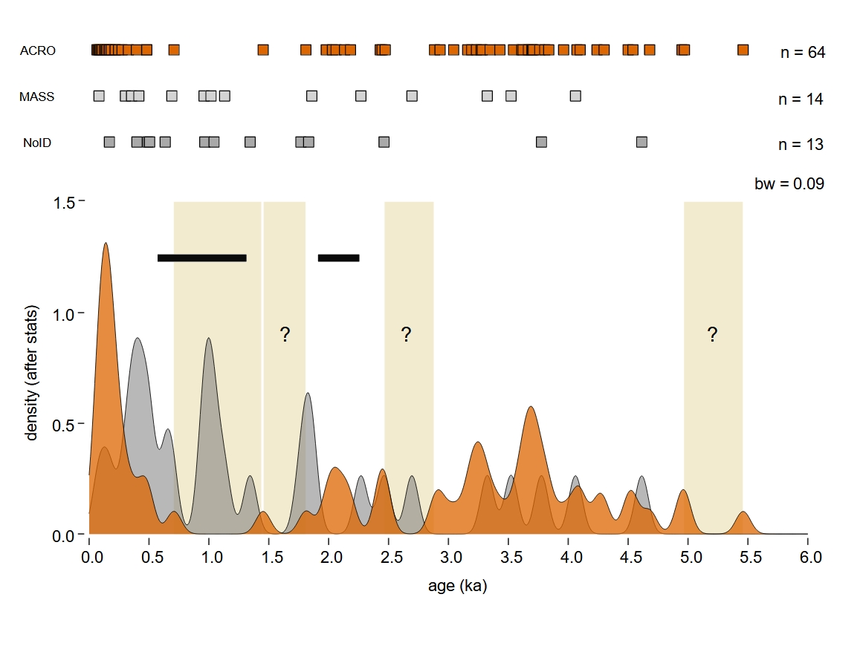

**Figure 2. Kernel Density Estimate of the Age-frequency distribution of coral clasts from the reef front at Punta Maroma (**Rplot27/26**).** Upper panel: near-surface U-series ages in calendar years arranged into 3 groups: ACRO (orange) branching *A. palmata* (n61) and *A. cervicornis* (n3), MASS (light grey) massive and submassive species (n14), and NoID (dark grey) non-acroporid samples without reliable identification (n13). Age uncertainties are smaller than the size of the box symbol used. Lower panel: Composite age-density plot (Kernel density estimates) showing periods of acroporid growth in orange separated by 4 centennial-scale gaps (0.71-1.45, 1.45-1.81, 2.47-2.88, 4.97-5.46 ka) highlighted with vertical bands. Non-acroporid growth in grey (combining MASS and NoID) fills acroporid gaps. The black bar represents an interval of anomalously high hurricane frequency recorded from Laguna Muyil, the closest coastal sediment record to Punta Maroma. KDE bandwidth (bw) was calculated using the Unbiased Cross Validation function of the stats R package.

**Statistical resampling**

To determine how sample size affects the age distribution of acroporids, Kernel Density Estimates based on resampled data are compared to the real age distribution. Random sample distributions (from one to 55), are subtracted from the acroporid age distribution to identify the temporal structure of the uncertainty (Fig. 3A). This procedure estimates total uncertainty in probabilistic terms, with unequal distributions yielding a difference of two, and equal distributions yielding a difference of zero. Results indicate that sample sizes larger than 35 yield differences of 0.1 or less between a resampled distribution and the actual age distribution (Fig. 3). Nevertheless, resampling is limited by the stochastic nature of data, which prevents extending the analysis to sample sizes beyond the range of available data.

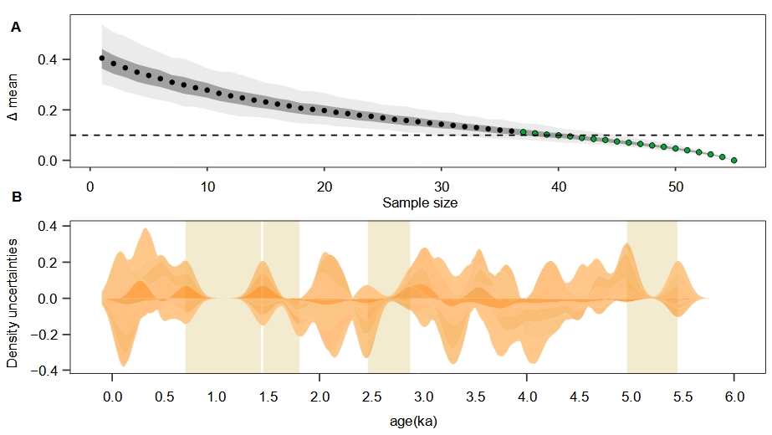

**Figure 3.** (Rplot21) **Acroporid sampling uncertainty**. **A:** absolute difference (delta) between the mean age distribution and the mean sample-size-based resampled distributions. Delta mean is represented along with a 95% confidence interval (light grey band) and interquartile sector (dark grey band) for each sample size. Green dots show sample-size estimates sufficient to describe the age distribution. The sample size sufficiency considers a low threshold of delta 0.1 in absolute mean differences between age and resampled age distributions. **B**: Uncertainties associated with gaps in age data (vertical bands). Uncertainties (95% confidence interval) cover three of the four gaps, indicating less reliable gaps in the acroporid record. Only the youngest gap is statistically robust.

Resampling is also applied to assess uncertainties associated with gap intervals observed in the age data (Fig.3B). This analysis shows that gaps not covered by the 95% confidence interval in the resampled distribution are statistically more reliable than those covered by it. The statistical analyses of resampled age data is tested by null model results (10,000 trials) which indicate that the chance of observing a 350-year (p = 0.007) or 750-year (p ≈ 0) growth gap in continuous distribution is highly unlikely (Supp. info). Both analyses therefore suggest that our 64 samples are sufficient to accurately describe the age trajectory of acroporids at Punta Maroma and that centennial-scale gaps in that trajectory are statistically anomalous.

**Hurricane gaps**

The presence of statistically anomalous centennial-scale gaps in the trajectory of acroporid growth at Punta Maroma helps eliminate short-term ecological disturbance as a cause. Disease outbreaks or bleaching, for example, are acute disturbances where recovery occurs on a sub-decadal scale due to the survival of skeletal architecture (Graham et al 2011; Dietzel et al., 2021). Hurricanes are also acute disturbances but recovery usually takes longer, sometimes decades, due to varying degrees of architectural damage (Stoddart, 1974; Connell, 1978). None of these types of acute disturbance, however, can account for the suppression of coral growth over centuries; this requires a more exceptional event such as a particularly intense hurricane strike, or an interval of frequent hurricanes. Indeed, statistical analysis has shown that anomalies in hurricane frequency arise stochastically over time (Wallace et al., 2014; 2021), and so could account for long-term gaps in acroporid trajectories.

To test the possibility that gaps result from intense or frequent hurricanes, we compare the growth trajectory of acroporids at Punta Maroma with an independent reconstruction of hurricane frequency from a coastal sediment archive. This archive, located in the northeast Yucatan and spanning the last 2 ka, is from Laguna Muyil, ~80 km south of Punta Maroma (Sullivan et al., 2022). It shows two intervals with hurricane frequency anomalies: persistent below-average frequency between 300-550 cal years ago, and persistent above-average frequency between 550-1300 cal years ago (Fig 2). These frequency anomalies partially correlate with acroporid growth at Punta Maroma, with growth-group 1 corresponding to reduced hurricane frequency between 300-550 cal years ago, and the gap between 700-1800 cal years coinciding with increased hurricane frequency between 550-1300 cal years (Fig 2). However a brief interval of frequent hurricanes from 2.25-1.90 ka aligns with acroporid growth showing that, without an intensity metric, it is difficult to assess hurricane impact on acroporid growth. In addition, the large distance between sites also increases the chance of missing strikes at either. As a consequence, hurricane-induced heterogeneity in the acroporid trajectory at Punta Maroma remains conjectural.

**Centennial-scale suppression of acroporid growth**

Despite the uncertainty of matching hurricane frequency with acroporid trajectories, the presence of centennial scale gaps at Punta Maroma implies that acroporid growth was suppressed for hundreds of years. This is a significant departure from the paradigm of ecological constancy and a continuous cycle of growth, disturbance, and recovery (Connell, 1978; Hughes, 1989; Brown, 1997; Connell et al., 1997; McManus and Polsenberg, 2004), which is assumed to have been the baseline condition during the Holocene and late Pleistocene (Jackson, 1992; Greenstein et al., 1998). Therefore, to assess the importance of this finding, we explore how frequent or intense hurricanes might suppress acroporid growth for centuries, then reconstruct acroporid trajectories from other areas to determine if gaps are common elsewhere, and conclude by comparing this baseline with the historical decline in acroporid growth, providing insight into its cause and future trajectory.

Several features of acroporid habitat and life history suggest an adaptation to physical disturbance, with hurricanes being the main driver of population dynamics (Fong and Lirman, 1995; Lugo et al., 2000; Gardner et al., 2005). First, monospecific thickets of *A. palmata* are restricted to reef-crest and frontal zones at depths less than 5 m, which coincide with the wave-breaking depth of low-intensity hurricanes (e.g., Category 2 hurricanes generate 3 m waves that break in 5 m of water; cf. Blanchon et al., 2017). Second, such shallow acroporid populations are thus chronically exposed to fragmentation by waves, fostering a reliance on asexual reproduction (Fong and Lirman, 1995; Irwin et al., 2017). Third, the rapid growth of cloned colonies and frequent low-intensity disturbance create ideal conditions for fragment propagation and habitat monopolisation, potentially leading to a continuous cycle of growth, disturbance, and recovery (Bruckner, 2002). An estimate of cycle length is given by the minimum age of acroporid genets whose long-lived clones can reach 800 years (Devlin-Durante et al., 2016; Irwin et al., 2017).

Although less intense hurricanes can maintain and augment growth trajectories, stochastic variations in frequency and intensity could produce anomalies that also suppress acroporid growth. (Wallace et al., 2014; 2021). This is exemplified by the catastrophic impact of Hurricane Hattie, a category 5 hurricane with 320 km/h winds and a 4-6 m storm surge, which struck the Belize Barrier Reef in 1961 (Stoddart, 1962). Surveys before and after the hurricane revealed severe damage over a 60 km belt centred on the hurricane track, with all shallow corals destroyed except for rare massive head colonies. The reef-front geomorphology was also flattened, with the destruction of spur-and-grooves and the deposition of skeletal traction carpets (Stoddart 1965; 1969). More than a decade later, the lack of recovery led Stoddart (1974) to conclude that it would take a century to return to a pre-hurricane state, 3 to 4 times longer than his initial estimate.

As surmised by Stoddart, the complete destruction of acroporids during such an intense hurricane would create a reliance on sexual reproduction, significantly delaying recovery. The absence of standing colonies would curtail sexual fertilisation success via the Allee effect and limit outcrossing with different genotypes to produce viable offspring (Levitan, 1991; Gascoigne and Lipcius, 2004; Boulon, 2005). Moreover, the accumulation of post-embryonic mutation in long-lived monoclonal populations increases the frequency of fertilisation failure in veteran genets, causing degeneration of life-traits associated with sexual reproduction and raising the risk of ecologically driven sexual extinction (Honnay and Bossuyt, 2005; Kuntz et al., 2020). Together, these factors impair sexual recruitment and reproduction after intense hurricanes, predisposing acroporid reefs to protracted intervals of recovery (Roff, 2021).

Given this impairment, the potential for discontinuities in acroporid trajectories rests on the return period of reef-destroying category-5 hurricanes. Intense hurricane strikes at any particular location are statistically improbable, suggesting average return periods spanning hundreds of years. Consequently, estimates based on the short 150-year historical record are unreliable (Emanuel and Jagger, 2010; Bloemendaal et al., 2020). Furthermore, return-period calculation is sensitive to the type of analysis, the choice of hurricane hazard variables, and local reef fetch (Bloemendaal et al., 2020). For instance, estimates using univariate metrics such as storm surge, wind speed, or precipitation yield return periods from 100 to 300 years (e.g., Resio et al., 2009; Keellings and Hernández Ayala, 2019). But basin-scale models which combine and synthesise these data over millennia predict return periods of 350-1000 years (Cho et al., 2023). Such centennial-scale return periods for intense hurricanes thus confirm the potential for growth discontinuities within multi-millennial intervals of reef development.

The recurrence of reef-destroying hurricanes coupled with impaired sexual reproduction is, therefore, consistent with a heterogeneous growth trajectory for acroporids. But why would reef recovery be suppressed for hundreds of years? The reason may relate to the radical alteration of substrate and benthos caused by intense hurricanes. First, the deposition of skeletal traction carpets generated by colony fragmentation creates an unstable substrate for coral recruitment, until removed by subsequent storms or stabilised by encrusters (Diaz and Rutzler, 2001; Viehman et al., 2018). Second, the destruction of corals and their geomorphic structures would create a flattened, barren substrate, eliminating the habitat of crustose corallines and other cohorts which facilitate recruitment (Ritson-Williams et al., 2010; Tebben et al 2015). Third, the import of sexual recruits from upstream sources would be limited by the short planktonic phase and dispersal distance of acroporids, increasing both the time required for recruitment and the chance of spat destruction by subsequent storms (Porto-Hannes et al., 2015; Teo and Todd, 2018; Japaud et al., 2019). These processes represent a habitat recolonization requiring centuries, not a recovery taking decades and, collectively, account for the centennial-scale gaps observed in the 5500-year trajectory of acroporid growth at Punta Maroma.

**Heterogeneous acroporid trajectories**

Despite the significant adversity posed by intense hurricanes, the growth trajectory at Punta Maroma shows that after ~700 years of absence, acroporids eventually recolonised their former habitat and resumed growth. The degree of growth constancy on any acroporid reef thus reflects local variation in hurricane frequency and intensity during its development (Connell et al., 1997), generating dissimilar acroporid trajectories among reefs; any coincidence between trajectories would require an alternative explanation.

Several studies have reported gaps in acroporid growth using age data from multiple sites over large areas (Fig. 4). For example, Shinn et al. (2003) measured 31 radiometric ages of *A. cervicornis* clasts across the Florida Reef Tract and found two gaps (3.0 and 4.5 ka) in the last 6 ka. But the subsequent inclusion of acroporid ages from local drill cores filled these gaps (Toth et al. 2019). Similarly, Hubbard et al. (2005; 2013) recovered 14 drill cores with 52 acroporid ages between 0.3-10.0 ka over a 20 km wide area off eastern St. Croix (Fig. 4B). They combined these local data with published *A. palmata* ages from the Caribbean, and found two gaps (5.9-5.2 ka and 3.0-2.2 ka), concluding they were consistent with regional episodes of disease or bleaching. Along the Belize Barrier Reef, Gischler et al. (2023) also reported coincident gaps over the last 9 ka (6.0-5.5 ka, 4.2-3.7 ka, and 2.7-2.0ka) from 20 cores with 127 ages (Fig. 4B). The problem with all of these large-area reconstructions is the low sample density at each site, which makes it impossible to determine if gaps are the result of absence or undersampling; only the timing of acroporid growth has any certainty.

More localised acroporid trajectories with higher ecological resolutions have only been reconstructed at a few sites. For example, both Aronson et al. (2002) and Greer et al. (2009) reported up to 3 ka of growth constancy in lagoonal *A. cervicornis* thickets from Belize and the Dominican Republic. However, reefs protected from open-ocean conditions are subject to fewer disturbances, increasing the likelihood of growth constancy over time.

In addition to our densely-sampled reconstruction from Punta Maroma, the only other open-ocean site where an acroporid trajectory can be reconstructed at an ecological resolution is Barbados (Fig. 4A). Data from the Oistins Bay offshore core site, originally used to reconstruct Postglacial sea level, consist of 4 drill cores with 81 acroporid ages from a submerged reef-crest that developed between 9-14 ka (Abdul et al., 2016). Further analysis of this sequence by Blanchon et al. (2021), however, showed frequent age reversals indicating that the deposit contained many clasts. Our reconstruction of acroporid growth using these data shows a relatively continuous trajectory with a single 350-year gap between 10.0-10.35 ka (Fig. 4A). Despite a high sample density, and statistical robustness of the gap from resampling and Monte Carlo simulation (Supp Info 3), it is unclear if the Barbados reconstruction is fully representative of the acroporid growth trajectory given the different objectives of the original study.

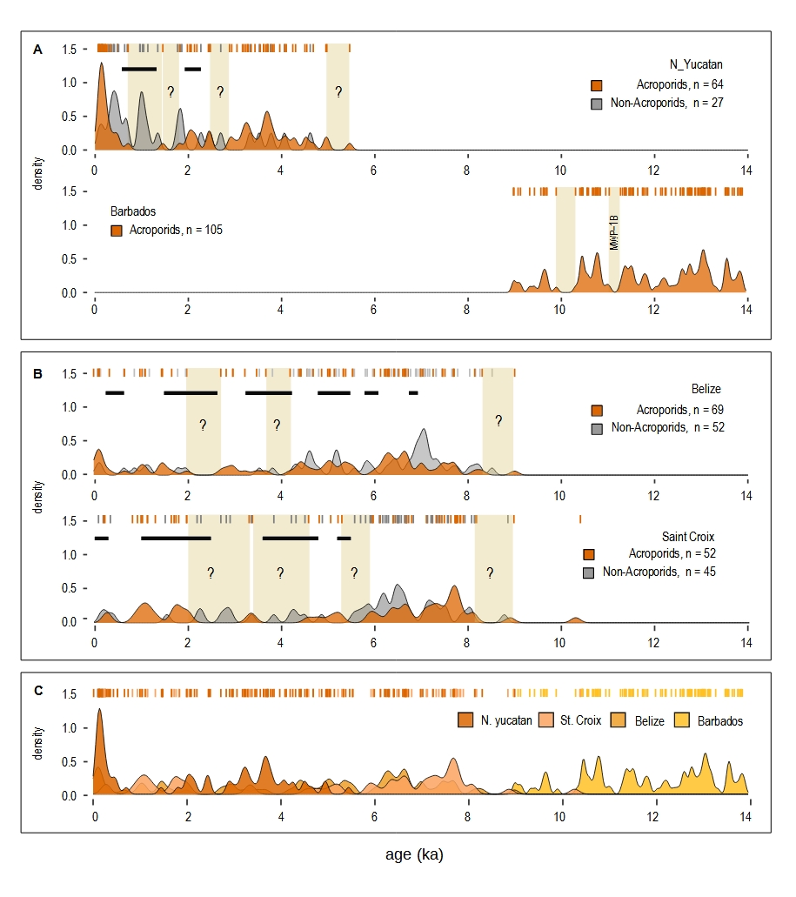**Figure 4. Kernel Density Estimates showing reconstruction of acroporid growth trajectories across the Caribbean** Rplot36 **A**. Centennial-scale gaps in high-resolution (<100 year) acroporid trajectories. Punta Maroma trajectory (this study) has a 83-year resolution (64 U-series ages over 5300 years), and several statistically anomalous gaps including one of 740 years (0.71-1.45 ka). Black horizontal lines denote intervals of high-hurricane frequency between 1.30-0.55 ka and 2.25-1.90 ka (Sullivan et al., 2022) which partly coincide with the youngest gap. Barbados trajectory has a 59-year resolution, (81 U-series ages over 4800 years), and a large statistically anomalous gap of 360 years (9.92-10.28 ka). KDE bandwidth calculated from an Unbiased Cross Validation function (stats, R- CRAN repo) for Punta Maroma data. **B**. Acroporid growth from low-resolution (>100 year) composite trajectories.Belize trajectory has a 134-year resolution (67 U-series and calibrated 14C ages over 9000 years) from 20 sites over ~200 km area (Gischler et al., 2023). St Croix trajectory has a 210 year resolution (49 U-series and calibrated 14C ages over 10,200 years) from 14 sites over a 20 km area (Hubbard et al., 2005; 2013). Gap integrity is uncertain given the low sample density at each site and high probability of undersampling; timing of growth is constrained by analytical age errors (<10%). Black horizontal lines denote high-hurricane-frequency intervals at St Croix (Donnelly & Woodruff 2007; Tang et al., 2024) and Belize (McCloskey and Liu 2013). KDE bandwidth is the same as for Punta Maroma data. **C.** Regional growthcomposite from all high- and low-resolution sites showing acroporid growth constancy over the last 14 ka.

If the drill sequence from Barbados accurately represents acroporid growth, then comparing high-resolution trajectories allows us to make two preliminary claims. First, both contain at least one statistically anomalous gap within a 5 ka reef-development interval, and one of these coincides with a positive hurricane-frequency anomaly derived from an independent coastal-sediment archive (Sullivan et al., 2022). It should be noted that, while some anomalies overlap with growth intervals, the sediment archive in question is 80-100 km from the reef site, meaning hurricanes could register in the archive yet bypass the reef.

Second, the centennial-scale gaps in the acroporid growth trajectory from Punta Maroma do not coincide with gaps at other sites. For example, the two gaps at Punta Maroma between 700 to 1800 cal years are filled by a growth interval at Buck Island on St. Croix, regardless of its lower resolution. Similarly, gaps in lower-resolution reconstructions from St. Croix are filled by growth at Punta Maroma and Belize. The dissimilarity of acroporid growth among reefs is thus consistent with the stochastic spatio-temporal variation in hurricane frequency which predicts that, although growth intervals might overlap, the gaps should not, given the improbability of simultaneous strikes by intense hurricanes.

**Baseline and future trajectory**

Our reconstruction of high-resolution acroporid trajectories from Punta Maroma and Barbados, and lower resolution trajectories from other sites (Fig 4), provide a Holocene baseline which places the historical decline of acroporids within a natural paleoecological context. Several conclusions can be drawn from this Holocene context.

First, the presence of centennial-scale gaps in acroporid trajectories during the last 14 ka predicts that historical reefs should have at least two ecological states: a ‘monopoly state’ where acroporids dominate the habitat, forming dense monospecific thickets on reef-crests exposed to open-ocean waves, and a ‘denuded state’ where acroporids are largely absent, and the habitat is dominated by other benthos. These two states represent reefs that have been either fully colonised by acroporids or require recolonization following destruction by an intense hurricane. Both states are consistent with early descriptions of Caribbean reefs made before their rapid decline. For example, in the now classic description of Jamaican reefs, Goreau (1959) contrasted the lush acroporid-dominated reef-crest and spur-and-groove zones along the north coast with the barren crests and absence of spur-and-groove along the south coast. He suggested these contrasting states represented a climax condition in the protected north and a regressive condition in the hurricane-prone south (Goreau, 1959). Reefs in a denuded state were also reported from the Alacran Reef complex, Mexico, by Kornicker and Boyd (1962), from San Andres and Providencia Islands, Colombia, by Geister (1977), and from the entire Eastern Caribbean by Adey and Burke (1976). Indeed, Adey et al. (1977) dated acroporids in drill cores from an eastern Martinique reef that gave a near-surface age of ~600 years, leading them to conclude that some may have been in a denuded state for hundreds of years.

Second, the centennial-scale gaps in high-resolution Holocene growth trajectories appear to be localised phenomena, with no regional-scale concordance (Fig. 4C). Although we can’t be fully certain of the integrity of all gaps, or that core-based sequences fully represent acroporid growth trajectories, the timing of acroporid growth at each site is incontrovertible. Thus, the reconstruction composite shown in Figure 4C confirms that acroporid growth has been regionally consistent across the Caribbean over the Holocene and late Pleistocene. The regional decline in acroporids over the last 50 years is therefore unprecedented over this 14 ka interval.

Finally, the unprecedented scale of the historical decline in acroporids implicates anthropogenic factors as playing a significant and ongoing role. Nevertheless, our reconstructions suggest that the proximate cause of this decline is the naturally low rate of sexual recruitment in acroporids, which inherently impairs recolonisation for hundreds of years following extreme disturbances. Human activities have merely added new types of extreme disturbance to natural ones, such as pollution-induced diseases (e.g., Sutherland et al., 2010) and warming-induced bleaching (e.g., Miller et al., 2006). This has increased the frequency of local acroporid extirpation, shifting more reefs to a denuded state, and increasing fragmentation and isolation of acroporid populations (Knowlton, 2001; Miller et al., 2018). The coupling of impaired recruitment and population isolation implies recolonisation of these sites is unlikely for hundreds of years into the future. Should this declining trend continue, the extinction of Caribbean acroporids looms as surviving reefs are eliminated one-by-one by future disturbance events, natural or otherwise (Knowlton, 2001; Aronson et al., 2008). Reversing this trend necessitates reducing the frequency of severe disturbance events, actively restoring acroporid populations on depleted reefs, and immediately protecting reefs where acroporids are still abundant.

**References**

Abdul, N. A., Mortlock, R. A., Wright, J. D. & Fairbanks, R. G. Younger Dryas sea level and meltwater pulse 1B recorded in Barbados reef crest coral *Acropora palmata*. *Paleoceanography* **31**, 330-344 (2016). https://doi.org/10.1002/2015PA002847

Adey, W. H. & Burke, R. Holocene bioherms (algal ridges and bank-barrier reefs) of the eastern Caribbean. *Geol. Soc. Am. Bull.* **87**, 95-109 (1976). 10.1130/0016-7606(1976)87<95:HBARAB>2.0.CO;2

Adey, W. H. & Burke, R. B. Holocene bioherms of Lesser Antilles--Geologic Control of Development: Modern and Ancient Reefs. *AAPG Stud. Geol.* **4**, 67-81 (1977).

Alvarez-Filip, L., Dulvy, N. K., Gill, J. A., Côté, I. M. & Watkinson, A. R. Flattening of Caribbean coral reefs: region-wide declines in architectural complexity. *Proc. R. Soc. B Biol. Sci.* **276**, 3019-3025 (2009). https://doi.org/10.1098/rspb.2009.0339

Alves, C. et al. Twenty years of change in benthic communities across the Belizean Barrier Reef. *PLoS ONE* 17, 1-36 (2022). https://doi.org/10.1371/journal.pone.0249155

Anderson, M. J. A new method for non‐parametric multivariate analysis of variance. *Austral Ecol*. 26, 32-46 (2001). https://doi.org/10.1111/j.1442-9993.2001.01070.pp.x

Anderson, M. J. *Permutational Multivariate Analysis of Variance (PERMANOVA)*. 18, 1–15 (John Wiley & Sons, 2014).

Aronson, R., Bruckner, A., Moore, J., Precht, B. & Weil, E. *Acropora palmata*. The IUCN Red List of Threatened Species. e.T133381A3716457 (2008). Retrieved from www.iucnredlist.org

Aronson, R. B., Macintyre, I. G., Precht, W. F., Murdoch, T. J., & Wapnick, C. M. The expanding scale of species turnover events on coral reefs in Belize. *Ecol. Monogr.* **72**, 233-249 (2002). https://doi.org/10.1890/0012-9615(2002)072[0233:TESOST]2.0.CO;2

Aronson, R. B. & Precht, W. F. Stasis, biological disturbance, and community structure of a Holocene coral reef. *Paleobiology* **23**, 326-346 (1997). https://doi.org/10.1017/S0094837300019710

Aronson, R. B., & Precht, W. F. White-band disease and the changing face of Caribbean coral reefs. *Hydrobiologia* **460**, 25-38 (2001). https://doi.org/10.1007/978-94-017-3284-0_2

Aronson, R. B., Precht, W. F. & Macintyre, I. G. Extrinsic control of species replacement on a Holocene reef in Belize: the role of coral disease. *Coral Reefs* **17**, 223-230 (1998). https://doi.org/10.1007/s003380050122

Audi, G., Bersillon, O., Blachot, J. & Wapstra, A. H. The NUBASE evaluation of nuclear and decay Aronson, R. B., Precht, W. F. & Macintyre, I. G. Extrinsic control of species replacement on a Holocene reef in Belize: the role of coral disease. *Coral Reefs* **17**, 223-230 (1998). https://doi.org/10.1007/s003380050122

Blanchon, P., Jones, B. & Kalbfleisch, W. Anatomy of a fringing reef around Grand Cayman; storm rubble, not coral framework. *J. Sediment. Res.* **67**, 1-16 (1997). https://doi.org/10.1306/D42684D7-2B26-11D7-8648000102C1865D

Blanchon, P., Medina-Valmaseda, A. & Hibbert, F. D. Revised postglacial sea-level rise and meltwater pulses from Barbados. *Open Quat*. **7**, 1-12 (2021). https://doi.org/10.5334/oq.87

Blanchon, P. & Perry, C. T. Taphonomic differentiation of *Acropora palmata* facies in cores from Campeche Bank Reefs, Gulf of Mexico. *Sedimentology* **51**, 53-76 (2004). https://doi.org/10.1046/j.1365-3091.2003.00610.x

Blanchon, P. et al. Retrograde accretion of a Caribbean fringing reef controlled by hurricanes and sea-level rise. *Front. Earth Sci.* **5**, 78 (2017). https://doi.org/10.3389/feart.2017.00078

Bloemendaal, N. et al. Generation of a global synthetic tropical cyclone hazard dataset using STORM. *Sci. Data* **7**, 40 (2020). https://doi.org/10.1038/s41597-020-0381-2

Boulon, R. et al. Atlantic Acropora status review document. Report to National Marine Fisheries Service, Southeast Regional Office, p. 152 (2005). https://repository.library.noaa.gov/view/noaa/16200

Brown, B. E. (1997). Adaptations of reef corals to physical environmental stress. *Adv. Mar Bio.* **31**, 221-299 (1997). https://doi.org/10.1016/S0065-2881(08)60224-2

Bruckner, A.W. *Proceedings of the Caribbean Acropora Workshop: Potential Application of the U.S. Endangered Species Act as a Conservation Strategy.* Silver Spring: NOAA Technical Memorandum NMFS-OPR-24, p. 199 (2002).

Bruno, J. F. & Valdivia, A. Coral reef degradation is not correlated with local human population density. *Sci. Rep.* **6**, 29778 (2016). https://doi.org/10.1038/srep29778

Bythell, J. & Sheppard, C. Mass mortality of Caribbean shallow corals. *Mar. Poll. Bull.* **26**, 296-297. (1993).

Cheng, H. et al. Improvements in 230Th dating, 230Th and 234U half-life values, and U–Th isotopic measurements by multi-collector inductively coupled plasma mass spectrometry. *Earth Planet. Sci. Lett.* **371–372**, 82-91. (2013). https://doi.org/10.1016/j.epsl.2013.04.006

Cho, E., Ahmadisharaf, E., Done, J. & Yoo, C. A multivariate frequency analysis framework to estimate the return period of hurricane events using event‐based copula. *Water Resour. Res.* **59**, e2023WR034786 (2023). https://doi.org/10.1029/2023WR034786

Connell, J. H. Diversity in tropical rain forests and coral reefs: high diversity of trees and corals is maintained only in a non-equilibrium state. *Science* **199**, 1302-1310 (1978). doi: 10.1126/science.199.4335.1302

Connell, J. H., Hughes, T. P. & Wallace, C. C. A 30‐year study of coral abundance, recruitment, and disturbance at several scales in space and time. *Ecol. Monogr.* **67**, 461-488 (1997).

Cramer, K. L. et al. Widespread loss of Caribbean acroporid corals was underway before coral bleaching and disease outbreaks. Science Advances 6, eaax9395 (2020). doi: 10.1126/sciadv.aax9395

Cramer, K. L. et al. The transformation of Caribbean coral communities since humans. *Ecol. Evol.* **11**, 10098-10118 (2021). https://doi.org/10.1002/ece3.7808

Davis, G. E. A century of natural change in coral distribution at the Dry Tortugas: a comparison of reef maps from 1881 and 1976. *Bull. Mar. Sci.* **32**, 608-623 (1982).

Devlin‐Durante, M. K., Miller, M. W., Caribbean Acropora Research Group, Precht, W. F. & Baums, I. B. How old are you? Genet age estimates in a clonal animal. *Mol. Ecol.* *25*, 5628-5646. (2016). doi: 10.1111/mec.13865

Diaz, M. C. & Rützler, K. Sponges: an essential component of Caribbean coral reefs. *Bull. Mar. Sci.* **69**, 535-546 (2001).

Dietzel, A., Connolly, S. R., Hughes, T. P. & Bode, M. The spatial footprint and patchiness of large‐scale disturbances on coral reefs. *Glob. Change Biol.* **27**, 4825-4838 (2021). https://doi.org/10.1111/gcb.15805

Donnelly, J. P., and Woodruff, J. D. Intense hurricane activity over the past 5,000 years controlled by El Niño and the West African monsoon. *Nature* **447**, 465-468 (2007). https://doi.org/10.1038/nature05834

Dustan, P. & Halas, J. C. Changes in the reef-coral community of Carysfort Reef, Key Largo, Florida: 1974 to 1982. *Coral Reefs* **6**, 91-106 (1987). https://doi.org/10.1007/BF00301378

Dutton, A. et al. Data reporting standards for publication of U-series data for geochronology and timescale assessment in the earth sciences. *Quat. Geochronol.* **39**, 142-149 (2017). https://doi.org/10.1016/j.quageo.2017.03.001

Eakin, C. M. et al. Caribbean corals in crisis: record thermal stress, bleaching, and mortality in 2005. *PloS ONE* **5**, e13969 (2010). https://doi.org/10.1371/journal.pone.0013969

Emanuel, K. & Jagger, T. On estimating hurricane return periods. *J. Appl. Meteorol. Clim.* **49**, 837-844 (2010). https://doi.org/10.1175/2009JAMC2236.1

Emanuel, K. Increasing destructiveness of tropical cyclones over the past 30 years. *Nature* **436**, 686-688 (2005). https://doi.org/10.1038/nature03906

Fong, P. & Lirman, D. Hurricanes cause population expansion of the branching coral *Acropora palmata* (Scleractinia): wound healing and growth patterns of asexual recruits. *Mar. Ecol.* **16**, 317-335 (1995). https://doi.org/10.1111/j.1439-0485.1995.tb00415.x

Gardner, T. A., Côté, I. M., Gill, J. A., Grant, A. & Watkinson, A.R. Long-term region-wide declines in Caribbean corals. *Science* **30,** 958–960 (2003). doi: 10.1126/science.1086050

Gardner, T. A., Côté, I. M., Gill, J. A., Grant, A. & Watkinson, A. R. Hurricanes and Caribbean coral reefs: impacts, recovery patterns, and role in long‐term decline. *Ecology* **86**, 174-184. (2005). https://doi.org/10.1890/04-0141

Gascoigne, J. & Lipcius, R. N. Allee effects in marine systems. *Mar. Ecol. Prog. Ser.* **269**, 49-59 (2004). doi:10.3354/meps269049

Geister, J. The influence of wave exposure on the ecological zonation of Caribbean coral reefs. *Proc. 3rd Int. Coral Reef Symp*. **1**, 23-29 (1977).

Gischler, E., Hudson, J. H., Eisenhauer, A., Parang, S. & Deveaux, M. 9000 years of change in coral community structure and accretion in Belize reefs, western Atlantic. *Sci. Rep.* **13**, 11349 (2023). https://doi.org/10.1038/s41598-023-38118-5

Gladfelter, W. B. White-band disease in Acropora palmata: implications for the structure and growth of shallow reefs. *Bull. Mar. Sci.* **32**, 639-643 (1982).

Gladfelter, E. H., Monahan, R. K., & Gladfelter, W. B. Growth rates of five reef-building corals in the northeastern Caribbean. *Bull. Mar. Sci.* **28**, 728-734 (1978).

Goreau, T. F. The ecology of Jamaican coral reefs I. Species composition and zonation. *Ecology* **40**, 67-90 (1959). https://doi.org/10.2307/1929924

Goreau, T. J. Bleaching and reef community change in Jamaica: 1951–1991. *Am. Zool.* **32**, 683-695 (1992). https://doi.org/10.1093/icb/32.6.683

Graham, N. A. J., Nash, K. L., & Kool, J. T. Coral reef recovery dynamics in a changing world. *Coral Reefs* **30**, 283-294 (2011). https://doi.org/10.1007/s00338-010-0717-z

Green, D. H., Edmunds, P. J. & Carpenter, R. C. Increasing relative abundance of *Porites astreoides* on Caribbean reefs mediated by an overall decline in coral cover. *Mar. Ecol. Prog. Ser.* **359**, 1-10 (2008). doi: https://doi.org/10.3354/meps07454

Greer, L., Jackson, J. E., Curran, H. A., Guilderson, T. & Teneva, L. How vulnerable is *Acropora cervicornis* to environmental change? Lessons from the early to middle Holocene. *Geology* **37**, 263-266 (2009). https://doi.org/10.1130/G25479A.1

Greenstein, B. J., Curran, H. A. & Pandolfi, J. M. Shifting ecological baselines and the demise of *Acropora* *cervicornis* in the western North Atlantic and Caribbean Province: a Pleistocene perspective. *Coral Reefs* **17**, 249-261 (1998). https://doi.org/10.1007/s003380050125

Haug, G. H., Hughen, K. A., Sigman, D. M., Peterson, L. C., & Rohl, U. (2001). Southward migration of the intertropical convergence zone through the Holocene. *Science* **293**, 1304-1308 (2001). doi: 10.1126/science.1059725

Hayes, M. L. et al. How are climate and marine biological outbreaks functionally linked? The Ecology and Etiology of Newly Emerging Marine Diseases. *Dev.Hydrob.* **159**, 213-220 (2001).https://doi.org/10.1007/978-94-017-3284-0_19

Hernández-Mendiola, E., Bernal, J. P., Lounejeva, E., Mortimer, G. E. & McCulloch, M. T. U-series dating of carbonates using inductively coupled plasma-quadrupole mass spectrometry. *Quat. Geochronol*. **6**, 564-573 (2011). doi: 10.1016/j.quageo.2011.09.001

Highsmith, R. C., Riggs, A. C. & D'Antonio, C. M. Survival of hurricane-generated coral fragments and a disturbance model of reef calcification/growth rates. *Oecologia* **46**, 322-329 (1980). https://doi.org/10.1007/BF00346259

Honnay, O. & Bossuyt, B. Prolonged clonal growth: escape route or route to extinction?.*Oikos* **108**, 427-432 (2005).

Hubbard, D. K., Zankl, H., Van Heerden, I. &Gill, I. P. Holocene reef development along the northeastern St. Croix shelf, Buck Island, US Virgin Islands. *J. Sediment. Res.* **75**, 97-113 (2005). doi: https://doi.org/10.2110/jsr.2005.009

Hubbard, D. K., Gill, I. P. & Burke, R. B. Holocene reef building on eastern St. Croix, US Virgin Islands: Lang Bank revisited. *Coral Reefs* **32**, 653-669 (2013). https://doi.org/10.1007/s00338-013-1041-1

Hughes, T. P. Community structure and diversity of coral reefs: the role of history. *Ecology* **70**, 275-279 (1989). https://doi.org/10.2307/1938434

Hugues, T. P. Catastrophes, phase shifts and large-scale degradation of a Caribbean reef. *Science* **265**, 1547-1551 (1994). doi: 10.1126/science.265.5178.1547

Hughes, T.P. et al. Climate change, human impacts, and the resilience of coral reefs. *Science* **301,** 929-933. doi: 10.1126/science.1085046. PMID: 12920289 (2003).

Hughes, T. P. et al. Phase shifts, herbivory, and the resilience of coral reefs to climate change. *Curr. Biol.* **17**, 360-365 (2007). Doi: 10.1016/j.cub.2006.12.049

Hughes, T. P. & Tanner, J. E. Recruitment failure, life histories, and long‐term decline of Caribbean corals. *Ecology* **81**, 2250-2263 (2000). https://doi.org/10.1890/0012-9658(2000)081[2250:RFLHAL]2.0.CO;2

Irwin, A. et al. Age and intraspecific diversity of resilient Acropora communities in Belize. *Coral Reefs* **36**, 1111-1120 (2017). https://doi.org/10.1007/s00338-017-1602-9

Jackson, J. B. Pleistocene perspectives on coral reef community structure. *Am. Zool*. **32**, 719-731 (1992). https://doi.org/10.1093/icb/32.6.719

Jackson, J., Donovan, M., Cramer, K. & Lam, V. Status and trends of Caribbean coral reefs: 1970-2012. *Global Coral Reef Monitoring Network, IUCN*, Gland, Switzerland (2014).

Jaffey, A. H., Flynn, K. F., Glendenin, L. E., Bentley, W. T. & Essling, A. M. Precision measurement of half-lives and specific activities of U 235 and U 238. *Phys. Rev.* C **4**, 1889-1906 (1971). https://doi.org/10.1103/PhysRevC.4.1889

Japaud, A., Bouchon, C., Magalon, H. & Fauvelot, C. Geographic distances and ocean currents influence Caribbean *Acropora palmata* population connectivity in the Lesser Antilles. *Conserv. Genet.* **20**, 447-466 (2019). https://doi.org/10.1007/s10592-019-01145-9

Jordan, E., Merino, M., Moreno, O. & Martin, E. Community structure of coral reefs in the Mexican Caribbean. *Proc. 4th Int. Coral Reef Symp.* **2**, 303–308 (1981).

Jordán-Dahlgren, E. Recolonization patterns of *Acropora palmata* in a marginal environment. *Bull. Mar. Sci.* **51**, 104-117 (1992).

Keellings, D. & Hernández Ayala, J. J. Extreme rainfall associated with Hurricane Maria over Puerto Rico and its connections to climate variability and change. *Geophys. Res. Lett.* **46**, 2964-2973 (2019). https://doi.org/10.1029/2019GL082077

Kornicker, L. S. & Boyd, D. W. Shallow-water geology and environments of Alacran Reef complex, Campeche Bank, Mexico. *Am. Assoc. Pet. Geol. Bull.* **46**, 640-673 (1962).

Knowlton, N. The future of coral reefs. *Proc. Natl. Acad. Sci. U.S.A.* **98**, 5419-5425 (2001). https://doi.org/10.1073/pnas.091092998

Knowlton, N. & Jackson, J. B. C. Shifting baselines, local impacts, and global change on coral reefs. *PLoS Biol.* **6**, e54 (2008). https://doi.org/10.1371/journal.pbio.0060054

Kuntz, K. L. V. et al. Inheritance of somatic mutations by animal offspring. *Science Advances* 8, 1-10 (2022). doi: 10.1126/sciadv.abn0707

Levitan, D. R. Influence of body size and population density on fertilization success and reproductive output in a free-spawning invertebrate. *The Biological Bulletin* **181**, 261-268 (1991).

Lirman, D. & Fong, P. Patterns of damage to the branching coral *Acropora palmata* following Hurricane Andrew: damage and survivorship of hurricane-generated asexual recruits. *J. Coastal Res.* **13**, 67-72 (1997). https://www.jstor.org/stable/4298591

Lugo, A. E., Rogers, C. S. & Nixon, S. W. Hurricanes, coral reefs and rainforests: resistance, ruin and recovery in the Caribbean. *Ambio* **29**, 106-114 (2000).

Lugo-Fernandez, A., Roberts, H. H. & Wiseman Jr, W. J. Tide effects on wave attenuation and wave set-up on a Caribbean coral reef. *Estuar., Coast. Shelf Sci.* **47**, 385-393 (1998). https://doi.org/10.1006/ecss.1998.0365

Ludwig, K. R. & Paces, J. B. Uranium-series dating of pedogenic silica and carbonate, Crater Flat, Nevada. *Geochim. Cosmochim. Ac.* **66**, 487-506 (2002). https://doi.org/10.1016/S0016-7037(01)00786-4

Macintyre, I. G., Glynn, P. W. & Steneck, R. S. A classic Caribbean algal ridge, Holandes Cays, Panama: an algal coated storm deposit. *Coral Reefs* **20**, 95-105 (2001). https://doi.org/10.1007/s003380000135

Manly, B. F. *Randomization, bootstrap and Monte Carlo Methods in Biology; Text in Statistical Science 3rd edn* (Chapman and Hall/CRC, 2018).

McClanahan, T. R. & Muthiga, N. A. An ecological shift in a remote coral atoll of Belize over 25 years. *Environ. Conserv.* **25**, 122-130 (1998). doi:10.1017/S0376892998000174

McCloskey, T. A. & Liu, K. B. A 7000 year record of paleohurricane activity from a coastal wetland in Belize. *The Holocene* **23**, 278-291 (2013).

McDonough, W. F. & Sun, S. S. The composition of the Earth. *Chem. Geol.* **120**, 223-253 (1995). https://doi.org/10.1016/0009-2541(94)00140-4

McManus, J. W. & Polsenberg, J. F. Coral–algal phase shifts on coral reefs: ecological and environmental aspects. *Prog. Oceanogr.* **60**, 263-279 (2004). https://doi.org/10.1016/j.pocean.2004.02.014

McWilliams, J. P., Côté, I. M., Gill, J. A., Sutherland, W. J. & Watkinson, A. R. Accelerating impacts of temperature‐induced coral bleaching in the Caribbean. *Ecology* **86**, 2055-2060 (2005). https://doi.org/10.1890/04-1657

Medina-Valmaseda, A.E., Rodríguez-Martínez, R.E., Alvarez-Filip, L., Jordán-Dahlgren, E., Blanchon, P. The role of geomorphic zonation in long-term changes in coral-community structure on a Caribbean fringing reef. *PeerJ* **8**, e10103 (2020). https://doi.org/10.7717/peerj.10103

Meyer-Arendt, K. J. Hurricane Gilbert: The storm of the century. *GeoJournal* **23**, 323-325 (1991). https://doi.org/10.1007/BF00193605

Miller, M., Crabbe, J., Villamizar, E., Croquer, A. & Banaszak, A. *Acropora palmata*. *The IUCN Red List of Threatened Species 2022*: e.T133006A165672016. (Accessed on 13 May 2024).

Miller, J., Waara, R., Muller, E. & Rogers, C. Coral bleaching and disease combine to cause extensive mortality on reefs in US Virgin Islands. *Coral Reefs* **25**, 418-418 (2006). doi:10.1007/s00338-006-0125-6

Miller, M. W. et al. Clonal structure and variable fertilization success in Florida Keys broadcast-spawning corals. *Coral Reefs* **37**, 239-249 (2018). https://doi.org/10.1007/s00338-017-1651-0

Mora, C. A clear human footprint in the coral reefs of the Caribbean. *Proc. R. Soc. Lond. B: Biol. Sci.* **275**, 767-773 (2008). https://doi.org/10.1098/rspb.2007.1472

Mudge, L. & Bruno, J. F. Disturbance intensification is altering the trait composition of Caribbean reefs, locking them into a low-functioning state. *Sci. Rep.* **13**, 14022 (2023). https://doi.org/10.1038/s41598-023-40672-x

Pandolfi, J. Coral community dynamics at multiple scales. *Coral Reefs* **21**, 13-23 (2002). https://doi.org/10.1007/s00338-001-0204-7

Pandolfi, J. M. & Jackson, J. B. Ecological persistence interrupted in Caribbean coral reefs. *Ecol. Lett.* **9**, 818-826 (2006). https://doi.org/10.1111/j.1461-0248.2006.00933.x

Perry, C. Storm-induced coral rubble deposition: Pleistocene records of natural reef disturbance and community response. *Coral Reefs* **20**, 171-183 (2001). https://doi.org/10.1007/s003380100158

Perry, C. T. et al. Caribbean-wide decline in carbonate production threatens coral reef growth. *Nat. Comm*. **4**, 1402 (2013). https://doi.org/10.1038/ncomms2409

Porter, J. W. & Meier, O. W. Quantification of loss and change in Floridian reef coral populations. *Am. Zool.* 32, 625-640 (1992). https://doi.org/10.1093/icb/32.6.625

Porto-Hannes, I. et al. Population structure of the corals *Orbicella faveolata* and *Acropora palmata* in the Mesoamerican Barrier Reef System with comparisons over Caribbean basin-wide spatial scale. *Mar. Biol.* **162**, 81-98 (2015). https://doi.org/10.1007/s00227-014-2560-1

Pratchett, M. S. et al. Spatial, temporal and taxonomic variation in coral growth—implications for the structure and function of coral reef ecosystems. *Oceanogr. Mar. Biol.***.:** *an Annual Review* **53**, 215-295 (2015).

Precht, W. F., Gintert, B. E., Robbart, M. L., Fura, R. & Van Woesik, R. Unprecedented disease-related coral mortality in Southeastern Florida. *Sci. Rep.* **6**, 31374 (2016). https://doi.org/10.1038/srep31374

Precht, W. F. & Miller, S. L. Ecological shifts along the Florida reef tract: the past as a key to the future. In *Geological approaches to coral reef ecology* (ed. Aronson, R.B.) 237-312. (Springer 2007).

Core Team. R: a language and environment for statistical computing. R Foundation for Statistical Computing, Austria, Vienna ( 2024). https://www.R-project.org/.

Randall, C. J. & Szmant, A. M. Elevated temperature affects development, survivorship, and settlement of the elkhorn coral, *Acropora palmata* (Lamarck 1816). *Biol. Bull.* **217**, 269-282 (2009).

Randall, C. J. & van Woesik, R. Contemporary white-band disease in Caribbean corals driven by climate change. Nat. Clim. Change **5**, 375-379 (2015). https://doi.org/10.1038/nclimate2530

Resio, D., Irish, J. & Cialone M. A surge response function approach to coastal hazard assessment – part 1: basic concepts, *Nat. Hazard.* **51**, 163–182 (2009). doi:10.1007/s11069-009-9379-y.

Ritson-Williams, R., Paul, V. J., Arnold, S. N. & Steneck, R. S. Larval settlement preferences and post-settlement survival of the threatened Caribbean corals *Acropora palmata* and *A. cervicornis*. *Coral Reefs* **29**, 71-81 (2010). https://doi.org/10.1007/s00338-009-0555-z

Roff, G. Evolutionary history drives biogeographic patterns of coral reef resilience. *Bioscience* **71**, 26-39 (2021). https://doi.org/10.1093/biosci/biaa145

Rogers, C. S. Degradation of Caribbean and Western Atlantic coral reefs and decline of associated fisheries. *Proc. 5th Int. Coral Reef Congr.* **6**, 491-496 (1985).

Rogers, C. S. & Muller, E. M. Bleaching, disease and recovery in the threatened scleractinian coral *Acropora palmata* in St. John, US Virgin Islands: 2003–2010. *Coral Reefs* **31**, 807-819 (2012). https://doi.org/10.1007/s00338-012-0898-8

Rodríguez-Martínez, R.E. Efectos de un ciclón en la estructura comunitaria de corales escleractinios. Bachelor Thesis. E.N.E.P. Iztacala. Universidad Nacional Autónoma México, México (1993).

Rodríguez-Martínez, R. E., Banaszak, A. T., McField, M. D., Beltran-Torres, A. U. & Alvarez-Filip, L. Assessment of *Acropora palmata* in the Mesoamerican reef system. *Plos ONE* **9**, e96140. (2014). https://doi.org/10.1371/journal.pone.0096140

Rützler, K. & Macintyre, I. G. The habitat distribution and community structure of the barrier reef complex at Carrie Bow Cay, Belize. The Atlantic barrier reef ecosystem at Carrie Bow Cay, Belize, I. structure and communities. Smithsonian Cont. Mar. Sci. **12**, 9-45 (1982).

Shinn, E. Spur and groove formation on the Florida reef tract. *J. Sed. Res.* **33**, 291-303 (1963). https://doi.org/10.1306/74D70E34-2B21-11D7-8648000102C1865D

Shinn, E. A., Reich, C. D., Hickey, T. D., & Lidz, B. H. Staghorn tempestites in the Florida Keys. *Coral Reefs* **22**, 91-97 (2003). https://doi.org/10.1007/s00338-003-0289-2

Stoddart, D. R. Three Caribbean atolls: Turneffe Islands, Lighthouse Reef, and Glover's Reef, British Honduras. *Atoll Res. Bull.* **87**, 1-151 (1962). doi: 10.5479/si.00775630.87.1

Stoddart, D. R. (1969). Post-hurricane changes on the British Honduras reefs and cays: re-survey of 1965. Atoll Research Bulletin.

Stoddart, D. R.. Carbonate sediments of Half Moon Cay, British Honduras. Atoll Research Bulletin (1964).

Stoddart, D. R. Re-survey of hurricane effects on the British Honduras reefs and clays. Nature (London);(United Kingdom), **207**, 4997 (1965).

Stoddart, D. R. Post-hurricane changes on the British Honduras reefs: re-survey of 1972. *Proc. 2nd Int. Coral Reef Symp.* 2, 473 (1974).

Shulman, M. J. & Robertson, D. R. Changes in the coral reefs of San Blas, Caribbean Panama: 1983 to 1990. *Coral Reefs* **15**, 231-236 (1996). https://doi.org/10.1007/BF01787457

Sutherland, K. P. et al. Human sewage identified as a likely source of white pox disease of the threatened Caribbean elkhorn coral, *Acropora palmata*. *Environ. Microbiol.* **12**, 1122-1131 (2010). https://doi.org/10.1111/j.1462-2920.2010.02152.x

Sullivan, R. M. et al. Northeast Yucatan hurricane activity during the Maya Classic and Postclassic periods. *Sci. Rep.* **12**, 20107 (2022). https://doi.org/10.1038/s41598-022-22756-2

Tang, H. et al. Mid-Holocene hydroclimatic change and hurricane activity in Central America recorded by an Isla de Mona Stalagmite. *Mar. Geol.* 147, 107289 (2024). https://doi.org/10.1016/j.margeo.2024.107289

Tebben, J. et al. Chemical mediation of coral larval settlement by crustose coralline algae. *Sci. Rep.* **5**, 10803 (2015). https://doi.org/10.1038/srep10803

Teo, A. & Todd, P. A. Simulating the effects of colony density and intercolonial distance on fertilisation success in broadcast spawning scleractinian corals. *Coral Reefs* **37**, 891-900 (2018). https://doi.org/10.1007/s00338-018-1715-9

Toth, L. T. et al. The unprecedented loss of Florida's reef‐building corals and the emergence of a novel coral‐reef assemblage. *Ecology* **100**, e02781 (2019). https://doi.org/10.1002/ecy.2781

Vecchi, G. A., Landsea, C., Zhang, W., Villarini, G. & Knutson, T. Changes in Atlantic major hurricane frequency since the late-19th century. *Nat. Commun.* **12**, 4054 (2021). https://doi.org/10.1038/s41467-021-24268-5

Vermeesch, P. IsoplotR: A free and open toolbox for geochronology. *Geosci. Front.* **9**, 1479-1493 (2018). https://doi.org/10.1016/j.gsf.2018.04.001

Viehman, T. S. et al. Understanding differential patterns in coral reef recovery: chronic hydrodynamic disturbance as a limiting mechanism for coral colonization. *Mar. Ecol. Prog. Ser.* **605**, 135-150 (2018). https://doi.org/10.3354/meps12714

Wallace, D. J., Woodruff, J. D., Anderson, J. B., & Donnelly, J. P. Palaeo Hurricane reconstructions from sedimentary archives along the Gulf of Mexico, Caribbean Sea and western North Atlantic Ocean margins. *Geological Society, London, Special Publications* **388**, 481-501 (2014). https://doi.org/10.1144/SP388.12

Wallace, E. J., Coats, S., Emanuel, K., and Donnelly, J. P. Centennial‐scale shifts in storm frequency captured in paleo hurricane records from The Bahamas arise predominantly from random variability. *Geophys. Res. Lett.* **48**, e2020GL091145 (2021). https://doi.org/10.1029/2020GL091145

Wapnick, C. M., Precht, W. F.& Aronson, R. B. Millennial‐scale dynamics of staghorn coral in Discovery Bay, Jamaica. *Ecol. Lett.* **7**, 354-361 (2004). https://doi.org/10.1111/j.1461-0248.2004.00586.x

Williams, D. E., Miller, M. W. & Kramer, K. L. Recruitment failure in Florida Keys *Acropora palmata*, a threatened Caribbean coral. *Coral Reefs* **27**, 697-705 (2008). https://doi.org/10.1007/s00338-008-0386-3

Woodley, J.D. The incidence of hurricanes on the north coast of Jamaica since 1870: are the classic reef descriptions atypical?. In: *The Ecology of Mangrove and Related Ecosystems* (eds. Jaccarini, V. & Martens, E.). Developments in Hydrobiology 80 (Springer, 1992). https://doi.org/10.1007/978-94-017-3288-8_14

**Supplementary Information**

**1. Historical Ecology at Punta Maroma**

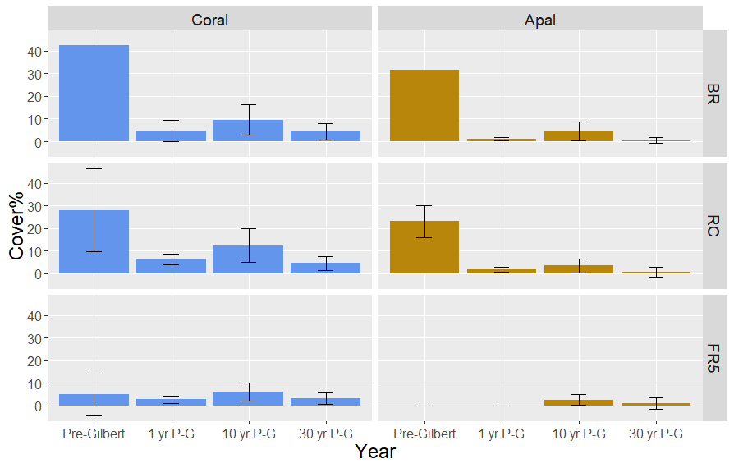

**Supplementary Figure 1.** Percent cover of corals and of *Acropora palmata* in three reef zones of Puerto Morelos reef during four sampling periods: Pre-Gilbert (1979-1985), and 1, 10, and 30 years Post-Gilbert (P-G). BR, back-reef, RC, reef crest, FR5, reef-front 5 m. Based on Rodriguez-Martinez (1993).

**2. Near-Surface age data**

**2.1. Total number of dated clasts** 101

**2.2. Pleistocene clasts** 10: from 30-109 ka,

**2.3. Age of Holocene clasts** 91: ranging from 60 to 5460 years = 60 year resolution

Acroporids clasts 64: ranging from 60 to 5460 years = 84 yr resolution

non-Acroporid 27: ranging from 80 to 4600 years

**2.4. Geomorphic age variation:**

reef-front total range:91 ages 60 to 5,500 years

Stump & Boulder (n 67) sampled area 400,000 m2 = 1 sample every 6417 m2

Spur & Groove: (n24) sampled area 200,000 m2 = 1 sample every 7916 m2

Total area ~0.7 km2

91 samples in 651,561 m2 = 1 sample every 7160 m2

Stump and Boulder zone: (n67) range 60 to 4500 years (av 1830)

Spur and Groove zone: (n24) range 113 to 5460 years (av 2930)

**2.5. Species composition vs zone**

Stump and Boulder (n67) Ap 73%, Non Ap 27%

Spur and groove (n24) Ap 40%, Non Ap 60%

**Supplementary Table 1. Age data per reef zone** (S&B, Stump and boulder; S&G, Spur and groove)

|  |  |  |  |  |  |  |
| --- | --- | --- | --- | --- | --- | --- |
| Zone (area km2) | Ap/Non Ap | Pit/Core | No. Reps | Ages | Av. Age | 土SD |
| Stump & Boulder (~0.4) | 49/18 | 35/4 | 1 | 67 | 1.83 | 0.02 |
| Spur & Groove (~0.2) | 15/9 | 17/6 | 0 | 24 | 2.93 | 0.03 |
|  | **64/27** | **52/10** | **1** | **91** | **2.38** | **0.03** |

**Supplementary Table 2. Age Resolution of data from Punta Maroma, St. Croix and Barbados**

|  |  |  |  |  |
| --- | --- | --- | --- | --- |
| **Species** | **Min. age (ka)**  **± SD** | **Max. age (ka)**  **± SD** | **Age Resolution** | **Area**  **Source** |
| **Other Species** | 0.0824 ± 0.0004 | 4.614 ± 0.02 | 84 | **Punta Maroma**  this paper |
| **Acroporids** | 0.06532 ± 0.0001 | 5.46 ± 0.03 |  |  |
| **Acroporids** | 9.003 ± 0.005 | 13.922 ± 0.06 | Oistins Bay  52 | **Barbados**  Abdul et al., 2016 |
| **Other Species** | 0.083 ± 0.004 | 8.521 ± 0.08 | 134 | **Belize**  Gischler et al., 2023 |
| **Acroporids** | 0.008 ± 0.01 | 9.002 ± 0.07 |  |
| **Other Species** | 0.15(0.285 - 0) | 8.765(8.97- 8.56) | Buck Island 405  Lang Bank 163 | **St. Croix**  Hubbard et al., 2005; 2013 ✝ |
| **Acroporids** | 0.265 (0.385 - 0.105) | 8.89 (8.985 - 8.776) |  |

✝ Ages from Hubbard et al, 2005 and Hubbard et al, 2013 correspond to calibrated 14C ages

**Supplementary Table 3:** U and Th activity ratios and 230Th-ages (ka) for coral samples from Punta Maroma.

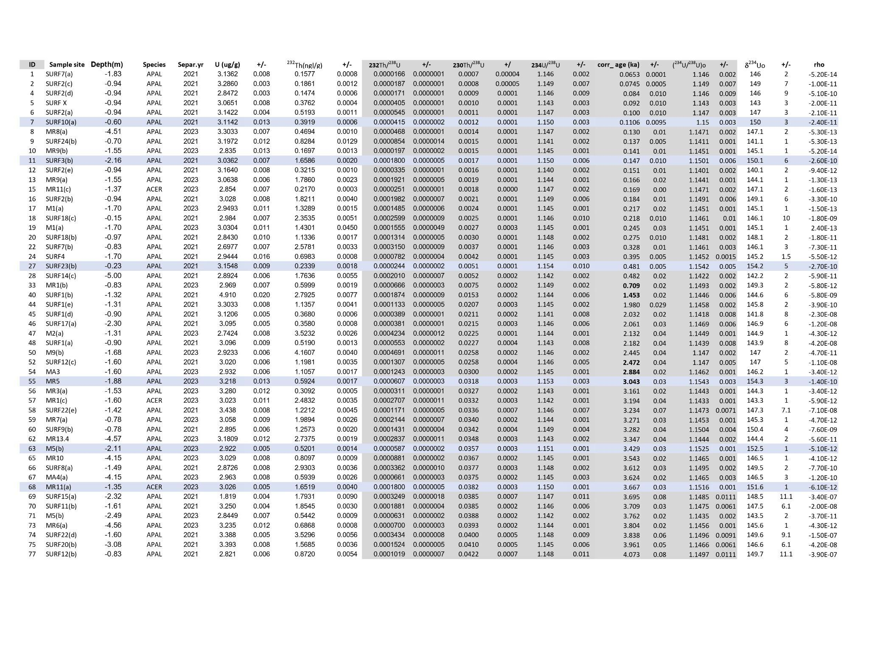

<https://docs.google.com/spreadsheets/d/1mwRVYl4r481THOeKWbQdtkS8vCHoCIdNZlspE0lq5H4/edit?usp=sharing>

**3. Statistical Analysis**

The raw data and code are available in the Supplemental Files and at Github:

[AlexisMedina2019/acroporid-centennial-gap-analysis](https://github.com/AlexisMedina2019/acroporid-centennial-gap-analysis)

**3.1 Resampling analysis of gap uncertainty in age data.**

The rationale behind using randomization techniques is to provide a visual representation of the differences in densities, which can be useful for evaluating uncertainty. Plotting the differences shows where densities diverge and by how much, which can provide insight into the reliability of the density estimates. Results show the quantity of data affects uncertainties associated with detected gaps. Densely sampled high-resolution data from Punta Maroma and Barbados exhibit similar uncertainties for gaps indicating they are statistically robust, whereas low-resolution data from St. Croix prevents similar conclusions. Additionally, the analysis for independent bandwidth selection penalised low-resolution data.

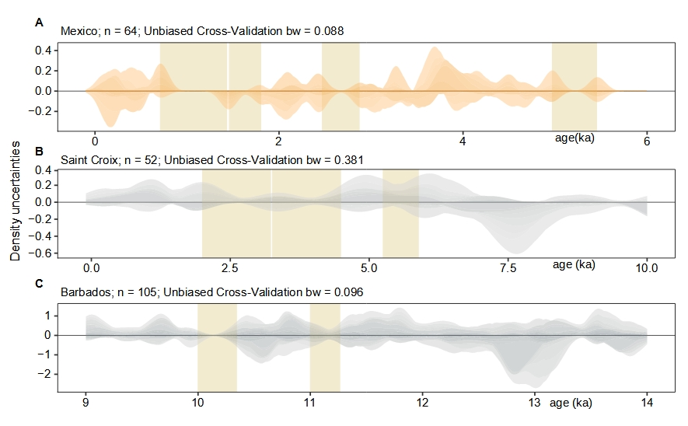

**Supplementary Figure 3.** **Gap uncertainties evaluation**. A visual outcome of the comparative analysis to assess uncertainties (95 confidence intervals) associated with gaps (vertical bands) in age data from selected sites: **Panel A**. Mexico (this study). **Panel B**. high-resolution data from Barbados and **Panel C** low-resolution from Saint Croix. The analysis was performed using independently calculated function-based bandwidths from the Unbiased cross-validation method of Stats R-package. Note how dataset quality affects both the bandwidth value and the uncertainties associated with gaps for each site. Whereas calculated bandwidth for high resolution data are similar in extension and close to a centennial value (0.088 and 0.096), the bandwidth from low-resolution data prevents a clear interpretation of the results.

**3.2 Monte Carlo Simulation to test Gap integrity and Null model rationale.**

The null model simulates random data from a theoretically continuous age distribution and estimates the likelihood of observing gaps of specific sizes. Procedural steps involve:

a) Random sampling within a specified range of 6000 years

b) Kernel Density Estimation (KDE) to approximate the underlying probability distribution of randomly sampled data.

c) Threshold and gap analysis to identify gaps in the density estimate that exceed a certain minimal gap span (according to the threshold of interest), representing intervals of low densities below the selected confidence interval

d) Computational and graphical representation of the probability of observing gaps larger than the threshold via multiple time estimations (N trials)

For our study, we used the following model settings:

1) KDE bandwidth was set to 100 years to assess centennial-scale gaps.

2) We considered 350 and 750-year gaps to assess observed gaps in the constructed KDE of high-resolution, field-based acroporid ages from Punta Maroma

3) The alpha complement for the confidence level was set to 0.05 so whenever age density estimates were below 0.05 probability, the interval was classified as a gap

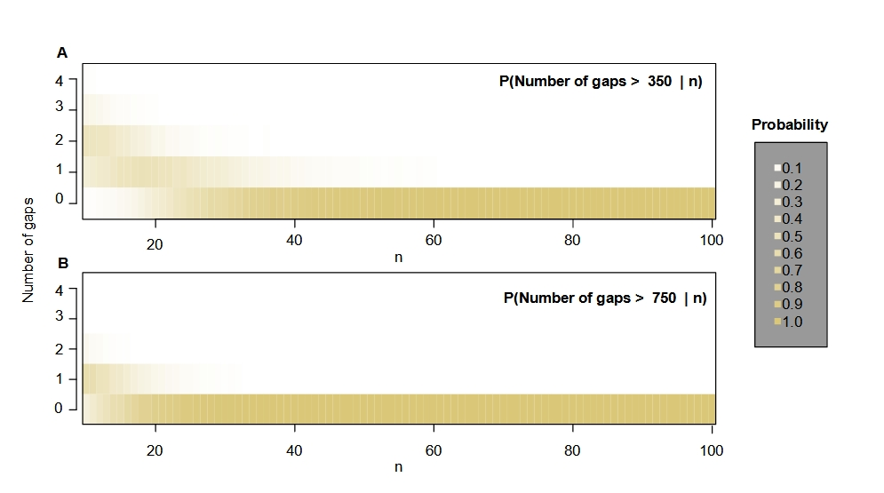

**Supplementary Figure 4. Gap probability with changes to random numbers of dates (n). A.** Plot shows how the probability of gap occurrence varies under null model conditions (threshold gap extension: 350yr, number of trials: 10k). Y-axis shows the number of gaps from 0 to 4 in response to the increased number of randomly selected dates (n) along the x-axis. Panel **B.** Similar plot showing a 750 yr gap size. Increase in colour intensity indicates an increasing gap probability, starting with white colour representing a probability less than 0.1 occurrence and the dark colour with a probability of 1.

**4. Pits and sampling sites at Punta Maroma**

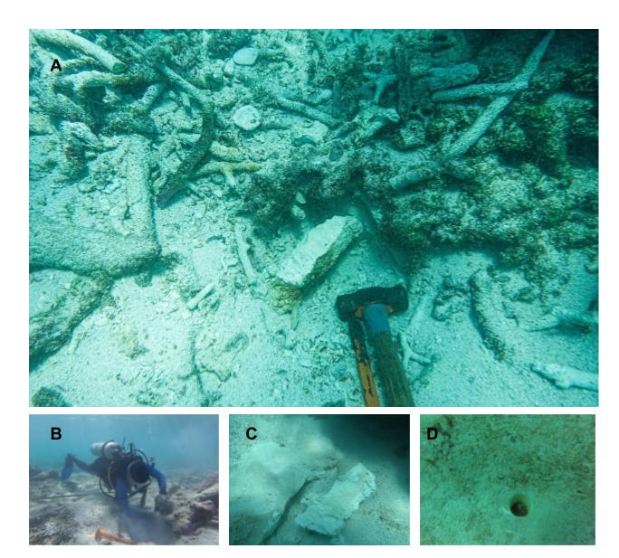

**Supplementary Figure 5.** **Reef Front Pits and Cores at Punta Maroma.** **A**. Close up showing surface and near surface composition of excavation into the reef-front substrate; clasts of branching *Acropora palmata* and *A. cervicornis* at 6 meters depth. **B.** Excavation in the barren consolidated substrate of the breaker zone at depth of <1 m. **C**. Sample of a boulder-sized *A. palmata* clast from shallow (2m) reef in front of breaker zone at central Punta Maroma. **D**. Drill-core sample from reef-front spur and groove zone.